# HW2

A. Do the data look like they could have come from a Poisson distribution with l = 1? Generate 10 tables as shown earlier, each having 100 scoops, using this distribution. Then make a qualitative conclusion regarding whether the model is “good.”

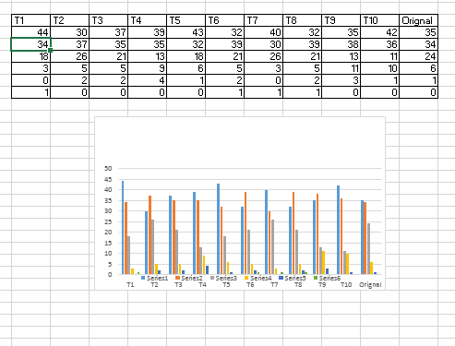

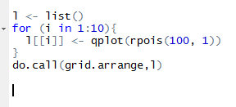

The above Graphs Generate is basically Good Model!!

Generated the Data by using the R function as well!

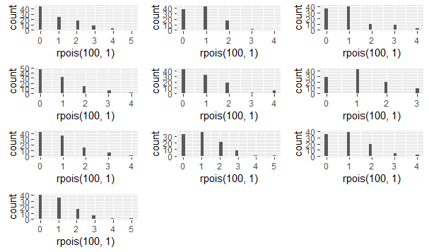

2.13)

1. The Data that has been produced by the normal distribution does not look like the normal distribution.

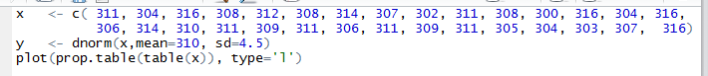

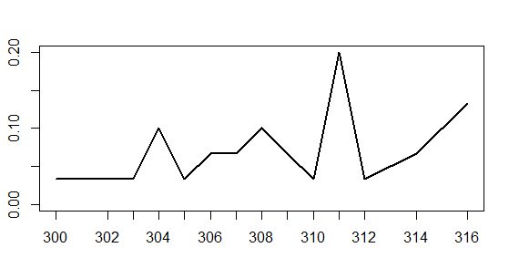

Generate 10 samples of n = 30 from this distribution, compare the resulting rounded-off numbers to those given, and make a qualitative conclusion regarding whether the model is good.

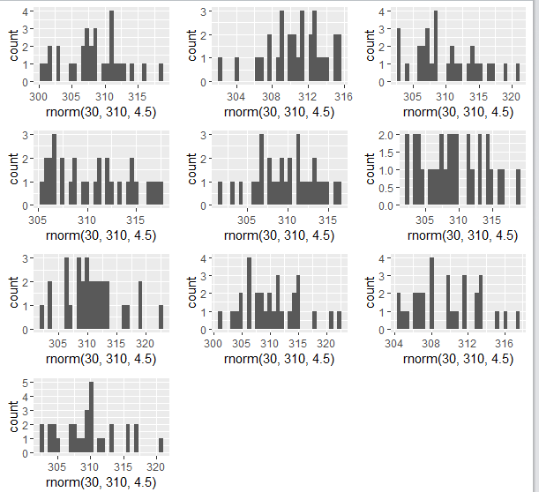

Ans: - Generated 10 different values (samples) and plotted on the graph and match with the original data, Data is not matching, that’s why it is not a good model.

2B) Assume the model with m = 310 and s = 4.5 is good—that is, that the process is running smoothly. Use the 10 repeated samples of 30 observations generated from the given normal distribution to answer the question, “Even when the process is running smoothly, how far can the chip width be from the target?”

Ans: - As observed from the above different observations in the sample generated the maximum and minimum ranges from (295-325) and that it is far chip width be from the target by the observed data.

2.15 Your colleague Hans claims that product preference is related to product complexity with an inverted “U” shape: When a product has too few features, people don’t like it because it does not do what they want it to do. When the product has too many features, people don’t like it because it does more than they want. His deterministic model is Preference = 6 + Complexity − 0.03 Complexity2, where the Complexity measure lies between 0 and 30.

1. Explain why Hans’ deterministic model is a bad model. To do so, consider 10 different people who evaluate a particular product with complexity 15.0. What does the model predict each of their preferences will be? Refer to Chapter 1 for the definition of a good model.

Ans: - It is not the Good model because even if we consider 10 different people the preference will be different some time preference with complexity might be 15 but sometimes preference with complexity might not be 15 so it is bad model.

B. Using the computer, draw a graph of the deterministic model that shows its maximum clearly. Label the axes “Complexity” and “Preference.”

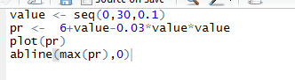

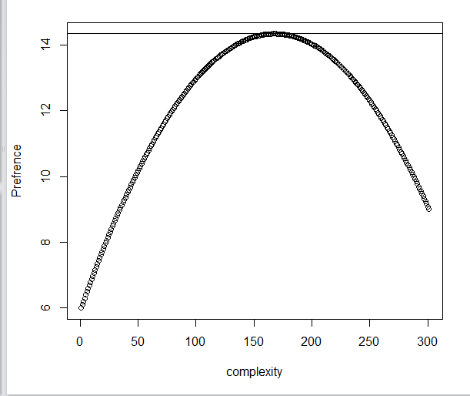

1. Using calculus, find the value of Complexity that produces maximum Preference when using this model. Give reasons for every step.

x = Complexity

y = Preference

df(x)/dx = d/dx (6 +x – 0.03x*x) = 0

Solving above derivative: -

0 = (0 +1 – 2(0.03x))

x = 100/6 = 16.67

2.18 Which of the following functions f(y) are pdfs? First, identify whether discrete or continuous, and then check the necessary conditions. In all cases, assume f(y) = 0 for values of y not given

A. f(y) = 1/6, for y = 1, 2, …, 6: - A function is Discrete and also the Pdf function as the Value because the sum of all the value is equal to 1

C. f(y) = 1/k, for y = 1, 2, …, k: - A function is Discrete and also the Pdf function as the Value because the sum of all the value is equal to 1

D. f(y) = y − 5.4, for y = 1, 2, …, 10: - A function is Discrete but it is not the Pdf function.

I. f(y) = 1/6, for 20 ≤ y ≤ 26: - A function is Continuous and also the Pdf function as the Value because the sum of all the value is equal to 1

J. f(y) = y2, for 0 < y < 1: - A function is Continuous but it is not the Pdf function.

K. f(y) = 1/y2, for 0 < y < 1: - A function is Continuous but it is not the Pdf function.